Strand 3 – Decomtamination Process (Brownfield Site)
A process (phytoremediation) has been developed that uses plants to remove contaminants from soils and water. Suppose a contaminated area (Brownfield site) in your town is being considered for this process. Identify at least three questions that would need to be answered before starting such a program. Write your answer in the space below.

Rubric For Decontamination Process
Possible Correct Responses:
• What is/were the sources of contamination?
• What are/were the contaminants of concern?
• What is the extent of the affected property?
• How deep does the contamination extend into the sediment?
• What are the potential effects on the local ecosystem/food webs?
• What type of ecological restoration is being sought (recreation, residential, etc.)?
• What is the timeframe needed for total restoration?
• What is the cost associated with this program compared to other programs?
• What special resources (tools, people, etc.) are required?
• Other acceptable questions.

3-Point Rubric:

Score 3
The response provides at least three relevant questions that would need to be answered before a town
implements a phytoremediation program.

Score 2
The response provides two questions that would need to be answered before a town implements a
phytoremediation program.

Score 1
The response provides one question that would need to be answered before a town implements a
phytorernediation program.

Score 0
The response provides little or no accurate or relevant information.

Sample Student Responses
Response #1 (3)
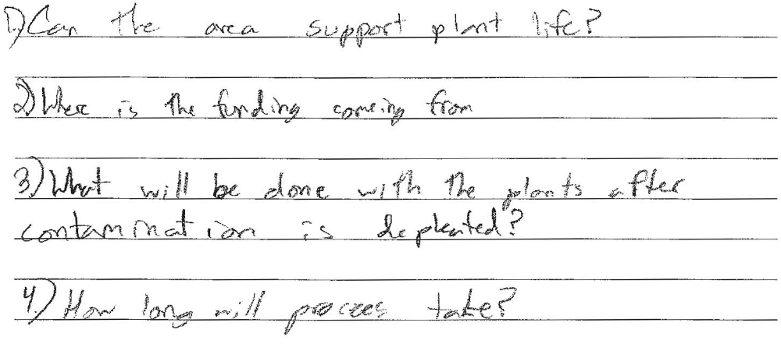
Response #2 (2)
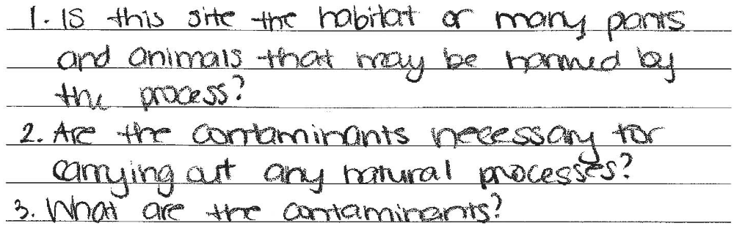

Response #3 (1)


Response #4 (0)

Response #5 (3)
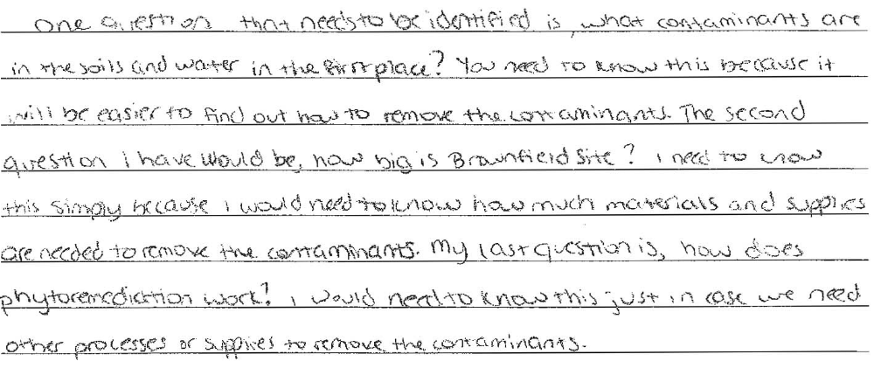

Response #6 (0)
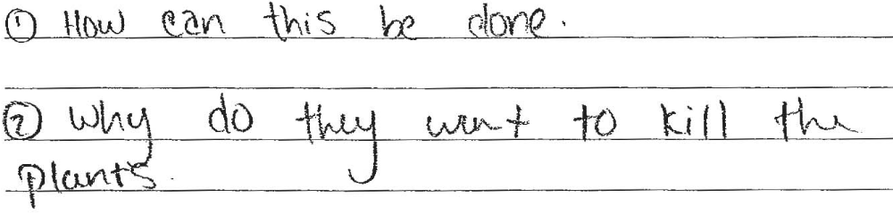

Response #7 (1)


